- WebDriver Commands:
Till now, we have successfully created our first test script in Selenium WebDriver. Therefore, one possible way to view the methods provided by WebDriver is to open the Eclipse IDE loaded with Selenium Webdriver jar files, create a driver object for WebDriver and press the dot key. It will show you all of the possible methods provided by WebDriver.

- Selenium WebDriver Commands
Let us consider an example form the suggestions displayed by Eclipse to understand the syntax of the methods provided by WebDriver.
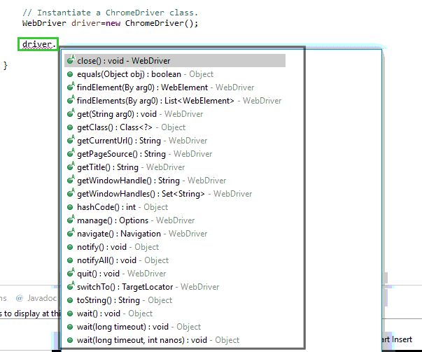

Method Name
To access any method of any class, we need to create an object of class and then all the public methods will appear for the object.
Parameter
A parameter is an argument which is passed to a method to perform some specific operation.
Return type
Methods can return a value or returning nothing (void). If the void is mentioned after the method, it means, the method is returning no value. If it is returning a value, then it must display the type of the value for e.g. getTitle(): String.

Now, we will discuss the various commands provided by WebDriver. The commands provided by Selenium WebDriver can be broadly classified in following categories:
- Browser Commands
- Navigation Commands
- WebElement Commands

Given below are some of the most commonly used Selenium commands in WebDriver:
1. Fetching a web page
There are two methods to fetch a web page:
Using Get method
driver.get("www.javatpoint.com")
Using Navigate method
driver.navigate().to("https://javatpoint.com/selenium-tutorial");

2. Locating forms and sending user inputs
driver.findElement(By.id("lst-ib")).sendKeys("javatpoint tutorials");

3. Clearing User inputs
The clear() method is used to clear the user inputs from the text box.
driver.findElement(By.name("q")).clear();

4. Fetching data over any web element
Sometimes we need to fetch the text written over a web element for performing some assertions and debugging. We use getText() method to fetch data written over any web element.
driver.findElement(By.id("element567")).getText();

5. Performing Click event
The click() method is used to perform click operation on any web element.
driver.findElement(By.id("btnK")).click();

6. Navigating backward in browser history
driver.navigate().back();

7. Navigating forward in browser history
driver.navigate().forward();

8. Refresh/ Reload a web page
driver.navigate().refresh();

9. Closing Browser
driver.close();

10. Closing Browser and other all other windows associated with the driver
driver.quit();

11. Moving between Windows
driver.switchTo().window("windowName");

13. Moving between Frames
driver.switchTo().frame("frameName");

14. Drag and Drop
Drag and Drop operation is performed using the Action class.
WebElement element = driver.findElement(By.name("source"));
WebElement target = driver.findElement(By.name("target"));
(new Actions(driver)).dragAndDrop(element, target).perform();

Imprortant Note: Difference between close() and Quit() - If you want to close only current window you can use close() and if you want to close all the associated windows and browser window use Quit()

Read more on: https://www.softwaretestinghelp.com/selenium-webdriver-commands-selenium-tutorial-17/

